Interactive Tutor Requirements Specification

**Version 1.0**

**September 25, 2017**

**Project Team:**

Amit Ranjan, Team Lead

David Edwards

Gary Chen

Tyler Wong

**Document Author(s):**

Amit Ranjan, Team Lead

**Customer Representative(s):**

The guy with the face…

**I. Introduction**

The goal of this project is to create a Java-version of Interactive Tutor system. This tutoring application allows users to learn in a fun an interactive way. This document describes the requirements of this program.

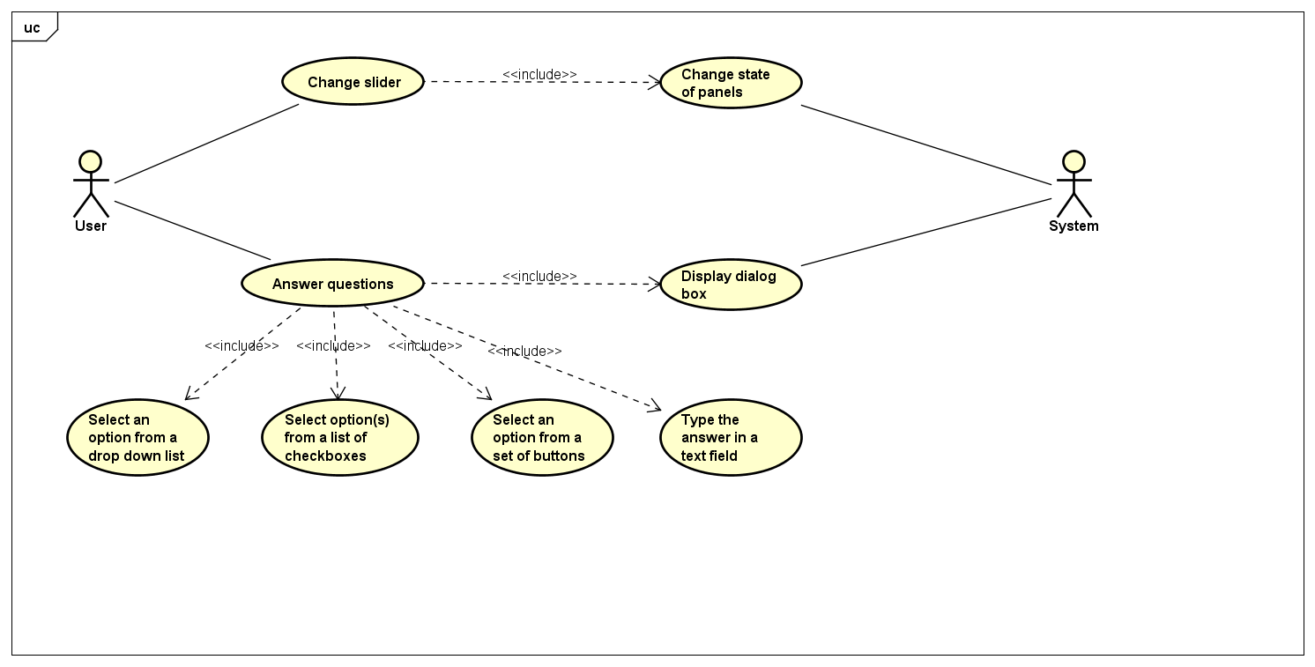

**II. Use Cases**

UC1 Change Slider

UC2 Answer Questions

UC3 Select an option from a drop down list

UC4 Select option(s) from a list of checkboxes

UC5 Select an option from a set of buttons

UC6 Type in the answer in the text field

UC7 Change state of panels

UC8 Display dialog box